**COMET BAY COLLEGE**

**Physics Unit 3 & 4 - Task 12**

**Quantum Test**

**Name: SOLUTION Total Marks /59**

**Question 1:**

There are six flavours of quarks (normal matter versions).

1. Determine the charge of the following particles that are made from quarks: (2 marks)

**-1 e (1 mark)**

**+1 e (1 mark)**

1. Bottom Xi prime $\left(dsb\right)$
2. Kaon-plus $\left(u\overline{s}\right)$
3. What family are these two particles from? (1 mark)

**Hadron (1 mark)**

1. Give an example from your studies of when a neutrino could come into existence. (2 marks)

**When a radioactive substance decays by beta plus decay (1 mark)**

**a neutrino is formed (along with a positron) (1 mark)**

**(Or words to that effect or another valid example.)**

**Question 2:**

Towards the end of the 20th century scientists suggested that quarks were the basic building blocks of protons and neutrons.

1. If a proton is made up of 3 quarks, what are the charges on each quark? (1 mark)

**+2/3, +2/3, -1/3 (1 mark)**

1. Explain your answer with reference to the charge only. (1 mark)

**The charge on a proton is +1.**

**Therefore the sum of charges on the three quarks must add to +1 (1 mark)**

**Question 3:**

Pauli’s exclusion principle is an important theory to consider when considering the behaviour of orbital electron. What is Pauli’s Principle and list the four quantum numbers? (5 marks)

**No two electrons in an atom could have all four quantum numbers identical. At least one must be different.  (1 mark)**

**These four quantum numbers are the;**

* **Principle quantum number (n) (1 mark)**
* **Orbital quantum number (l)  (1 mark)**
* **Orbital magnetic quantum number (ml) (1 mark)**
* **Spin quantum number (ms)  (1 mark)**

**Question 4:**

Tonic water contains quinine and is a clear liquid under normal lighting conditions. When UV light shines onto tonic water it starts to glow with a distinct blue colour. This is because of the process of fluorescence. One of the atoms in quinine has a ground state energy level value of -9.10 eV. It is excited to Energy Level 3 (E3) by a UV photon of wavelength 322 nm. A blue photon of wavelength 469 nm is emitted in a de-excitation from E3 to E2.

1. On the diagram below show and label the electron transitions taking place that give rise to the observed phenomenon. (2 marks)

E1

E2

E3

-9.10 eV

**-7.89**

**-5.24**

**De-excitation and emission of blue photon (1 mark)**

**Excitation by absorption of UV photon (1 mark)**

1. Calculate the value of Energy Levels 2 and 3 (eV) and show them on the diagram. Show your working in the space below. (4 marks)

**Consider UV photon**

**E = h.f = h.c / λ = 6.63 x 10-34 x 3 x 108 / 322 x 10-9**

**E = 6.177 x 10-19 J = 6.177 x 10-19/1.60 x 10-19 = 3.86 eV (1 mark)**

**E3 = -9.10 + 3.86 = -5.24 eV (1 mark)**

**Consider blue photon**

**E = h.f = h.c / λ = 6.63 x 10-34 x 3 x 108 / 469 x 10-9**

**E = 4.24 x 10-19 J = 4.24 x 10-19/1.60 x 10-19 = 2.65 eV (1 mark)**

**E2 = -5.24 -2.65 = -7.89 eV (1 mark)**

1. Determine the wavelength (nm) of the other photon that can be emitted in this fluorescence process by a transition from E2 and state whether it is visible or not. (refer to the data sheet to justify your answer). (4 marks)

**E2 to E1 = -9.10 – (-7.89) = 1.21 eV (1 mark)**

**Consider photon**

**E = = 1.21 x 1.60 x 10-19 = 1.936 x 10-19 J (1 mark)**

**λ = h.c/E = 6.63 x 10-34 x 3 x 108 / 4.976 x 10-19**

**λ = 1.027 x 10-6 = 1027 nm (1 mark)**

**With reference to data sheet = Infra Red (1 mark)**

**Question 5:**

The age of the Universe is predicted to be about 14 Gy. Demonstrate, using a known method, that this is the age the Universe is predicted to be? (3 marks)

You may need to use the following data;

* H0 = 71 km/s/Mpc
* 1 pc = 3.08 x 1016 m

**H0 = (71 km s-1 Mpc-1) ÷ (3.08 x 1019 km)  (1 mark)**

**= 2.3052 x 10-18 s-1.**

**So the age of the Universe is**

**t = 1/H0**

**= 1 / 2.3052 x 10-18 s  (1 mark)**

**= 4.338 x 1017 s  (1 mark)**

**= 13.8 billion years.**

**Question 6:**

Feynman’s Diagrams are used in sorts to explain the interactions between particles and the interactions between sub-atomic particles.

1. Explain the diagram below and show it works using the conservation of Baryons, Leptons and Charges. (5 marks)

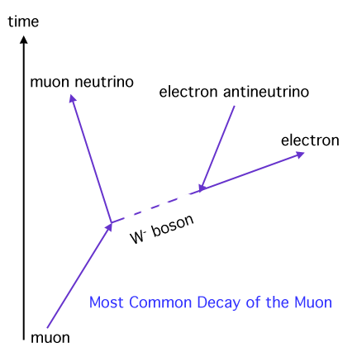

1. an electron meets a positron and they are annihilated
2. Draw a Feynman’s Diagram showing the process (2 marks)

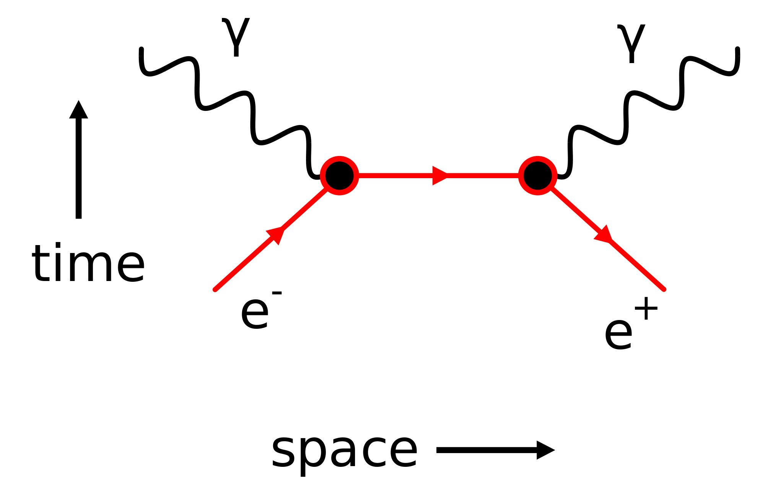

1. Calculate the energy released when they are annihilated. (2 marks)

**Question 7:**

An apparatus used for identifying minerals in mining samples involves releasing electrons from a cathode electron gun and accelerating them across a potential difference and through a pair of parallel charged plates and then impacting with the sample. The electrons are accelerated through a potential of 35 kV, and through a distance of 330 mm between the charged plates.



1. Calculate the strength of the electric field between the charged plates. (3 marks)

**potential = 35 kV**

**distance between plates = 330 mm**

**charge on electron = -1.6 x 10-19 C**

**mass of electron =9.11 x 10-31 kg  (1 mark)**

**magnetic field strength = 0.300 T**

**Electric field strength = V/d**

**Electric field strength = 35 x 103 / 0.33  (1 mark)**

**Electric field strength = 1.06 x 105 N C-1  (1 mark)**

1. Calculate the magnitude of the velocity of the electrons as they exit the electron gun assembly. (3 marks)

**Energy = W = q V**

**Energy = (-1.6 x 10-19) x 35 x 103  (1 mark)**

**Energy = 56 x 10-16 J**

**Energy (KE) = ½ m v2**

**(56 x 10-16) = ½ (9.11 x 10-31) x v2  (1 mark)**

**v2 = (56 x 10-16) x 2 / (9.11 x 10-31) = 122.9 x 1014**

**v = 1.11 x 108 m s-1  (1 mark)**

1. After leaving the electron gun assembly, the electrons travel through a uniform magnetic field which is perpendicular to their direction of motion. If the magnetic field strength is 0.300T, through what radius will the electrons be deviated? (3 marks)

F = qvB = m v2/r **(1 mark)**

q B = m v/r so r = m v / q B

r = (9.11 x 10-31) x (1.11 x 108) / (1.60 x 10-19) x 0.300 **(1 mark)**

r = 0.0021 x 10-3 m **(1 mark)**

The radius is 2.1 mm

**Question 8:**

The distances to galaxies can be estimated by observing Cepheid Variables within a galaxy. A Cepheid Variable is a class of star that pulsates. The relationship between the period of pulsation and the size of the star is very precise. An understanding of how brightness diminishes with distance allows astronomers to estimate distances to galaxies with a high degree of confidence.

The following data was recorded by the Hubble Space Telescope for five galaxies.

|  |  |  |
| --- | --- | --- |
| Distance  (Mpc) | Red shift - z | Recessional speed of galaxy vgalaxy (km s-1) |
| 3.1 | 0.00095 | 285 |
| 8.6 | 0.00212 |  |
| 12.2 | 0.00273 |  |
| 16.1 | 0.00402 |  |
| 19.4 | 0.00473   |  |  |  | | --- | --- | --- | | Distance  (Mpc) | Red shift - z | Recessional speed of galaxy vgalaxy (km s-1) | | 3.1 | 0.00095 | 285 | | 8.6 | 0.00212 | **636** | | 12.2 | 0.00273 | **819** | | 16.1 | 0.00402 | **1206** | | 19.4 | 0.00473 | **1419** | |  |

1. Fill in appropriate values in the final column of the table (the first value has been done for you) (2 marks)

**Minus 1 mark for each incorrect. As above**

1. Plot a correctly labelled graph of recessional speed versus distance to galaxy on the graph paper and draw a line of best fit . (4 marks)



graph paper C whirlygig 8 by 10

**Correct plotting (1 mark)**

**labels  (1 mark)**

**units  (1 mark)**

**line of best fit  (1 mark)**

1. Calculate a value for Hubble’s constant, in the correct units, showing how you obtained this value from your graph. (3 marks)

**Identifies rise and run on line of best fit (1 mark) (not data points)**

**H0 = gradient = rise / run**

**H0 = 1440 / 20 (1 mark)**

**H0 = 72.0 km s-1 Mpc-1 (1 mark)**

**Allow small range for “line of best fit” variations.**

1. State three reasons why you think that measurements of Hubble’s constant have varied widely since Hubble’s first determination in 1920. (3 marks)

* **Improved technology to measure red shift (diffraction gratings)**
* **Better telescopes (e.g. Hubble and others located in space – no atmospheric distortion.)**
* **More Cepheid Variables discovered – better averages on distance measurements.**

**Any 3 credible points**

**Question 9:**

|  |  |
| --- | --- |
| **Particle** | **Quarks** |
| Kaon-minus |  |
| Pi-plus (π+) |  |
| Sigma-plus |  |
| Lambda-zero |  |
| Charmed Omega |  |

There are six flavours of quarks (normal matter versions) and six flavours of antiquarks. A combination of these quarks and antiquarks form particles similar to those commonly known – protons and neutrons. To the right is a table showing other such particles and their quark combinations.

1. Determine the charge (coulombs) of the Lambda-zero: (1 mark)

**(+2/3) + (-1/3) + (-1/3) = 0 C (1 mark)**

1. Determine the charge (coulombs) of the Kaon-minus: (1 mark)

**(-1/3)+(-2/3) =-1C (1 mark)**

1. Briefly explain why quarks of like charge are not repelled from each other in a hadron.

(2 marks)

**Any reasonable statement**

**(residual) strong nuclear force / colour charge / gluon exchange (1 mark)**

**leading to attractive force stronger than electromagnetic repulsion between individual quarks (1 mark)**